Project 3 - Neural Network Project

Consider the Parkinson's Disease Classification Data set on the web site: [https://archive.ics.uci.edu/ml/datasets/Parkinson%27s+Disease+Classification#](https://archive.ics.uci.edu/ml/datasets/Parkinson%27s+Disease+Classification)

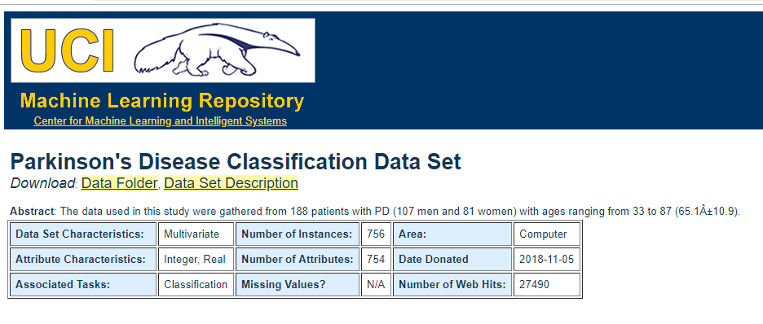

Click on the 'Data Folder' (red box in the image above to download the data set file. After download completes, you will see a file named 'pd_speech_features.rar'. To open the file your need to have the free rar software, if you do not have this program then downloaded by typing in the Google Search 'rar program download' and install it. For Mac students, you need to type in Google search 'rar Linux install' and follow website directions. The same file can be downloaded from Blackboard. I posted it in the same section as this assignment's section.

The file has 754 features and 756 examples. You are required to use neural network to learn the data. Choose suitable neural network architecture, find the best alpha, then measure the training error and dev error. Change the neural network architecture to find the best one (minimum dev error). For each neural network architecture, determine if it suffers from high bias or high variance.

What is required from you is to use the program forwardAndBackProp_2.py in Blackboard to find the minimum JDev(θ). Play with α, λ and the number of iterations to get the minimum error.

Bonus, increase the number of layers and get a better dev error.

Make sure your code runs correctly with no errors and display the graphs and training, dev, and test errors. Send me you complete code on Blackoard.